PROFILES FOR THE 7TH NATIONAL BIOSAFETY COMMITTTEE (7TH NBC)
BIODATA BARBARA M. ZAWEDDE, PhD
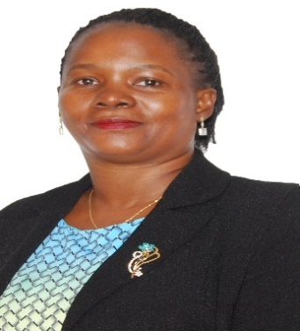
Dr. Barbara Mugwanya Zawedde is the Principal Technology Promotion Officer at the National Agricultural Research Organization (NARO), Uganda. She has been involved in development of the Uganda’s biosafety system since 2003. She has a PhD in Plant Breeding, Genetics and Biotechnology with a Doctoral Specialization in Environmental Science and Policy. She coordinated the Uganda Biosciences Information Centre (UBIC) from August 2013 to March 2020, and a Vice Chairperson of the Uganda Biotechnology and Biosafety Consortium (2014 to 2019), which were critical Science Communication initiatives that supported the National Biosafety legislation development process and got the Biosafety Bills approved two times in the Parliament (2017 and 2018).
She previously supported processes of the National Biotechnology and Biosafety Policy (2008) formulation and development of the National Guidelines for Biosafety Containment and Confinement, the Trial Managers’ Handbook, a draft National Biosafety Communication Strategy (2020) to mention a few. She provided regulatory backstopping for biotechnology projects including WEMA and VIRCA project as an internal project regulator. She has participated in capacity building of other biosafety regulators beyond Africa. She has participated in CBD COP-MOP negotiations. Recently she was a Director of Research for one of the NARO Institutes. She has been the Chairperson of the NARO Institutional Biosafety Committee (IBC) since April 2019 up to August 2025. She is the Vice Chairperson for the 7th National Biosafety Committee.
Relevant Projects and Publications
Principal Investigator: NextGen Cassava Project (Biotechnology and Biosafety Education and Outreach), funded by Bill and Melinda Gate Foundation, 2013- 2017
Co-Implementer, NextGen Cassava Project (Biotechnology and Biosafety Education and Outreach), funded by Bill and Melinda Gate Foundation, 2013- 2017
Co-PI, John Templeton Foundation Grant to Africa Biosafety Network of Experts (Assessing the Biotechnology Regulatory Frameworks in Africa), 2012-2013
Principal Investigator: Borlaug LEAP Research Grant: Farmers’ survey to evaluate the trait preferences and conservation of sweetpotato biodiversity, funded by the Norman E. Borlaug Leadership Enhancement in Agriculture Program (Borlaug LEAP) 2011
Zawedde B.M. et al (2025) Uganda’s evolving national biosafety system: lessons from the past 30 years. https://doi.org/10.3389/fbioe.2025.1654335
Ongu I, et al., Zawedde B.M., Eriksson D, 2023. Biosafety regulatory frameworks in Kenya, Nigeria, Uganda and Sweden and their potential impact on international R&D collaborations. doi:10.1080/21645698.2023.2194221
Wagaba H. et al., Zawedde M.B., 2021. Comparative compositional analysis of cassava brown streak disease resistant 4046 cassava and its non-transgenic parental cultivar. doi:10.1080/21645698.2020.1836924
Tibasaaga, A., Zawedde, B. M. 2018. Science Communication Models for Agricultural Transformation in Uganda. doi:10.4314/ujas.v18i2.6
Zawedde B.M. et al., 2018. Readiness for Environmental Release of Genetically Engineered (GE) Plants in Uganda. https://doi.org/10.3389/fbioe.2018.00152
Zawedde M. B. et al. 2014. Assessment of on-farm sweetpotato diversity, and factors influencing the level of farmers’ crop diversity: Implications for conservation. DOI: 10.1007/s12231-014-9278-3
Zawedde M. B. et al. 2014. Characterization of the genetic diversity of Uganda’s sweetpotato germplasm using microsatellites. Genetic Resources and Crop Evolution. DOI: 10.1007/s10722-014-0175-5
Zawedde M. B. et al. 2012. Policies & Laws of Relevance to Regulation of Agricultural Biotechnology in Uganda. Policy Brief No. 3, 2012. Uganda Biotechnology and Biosafety Consortium.

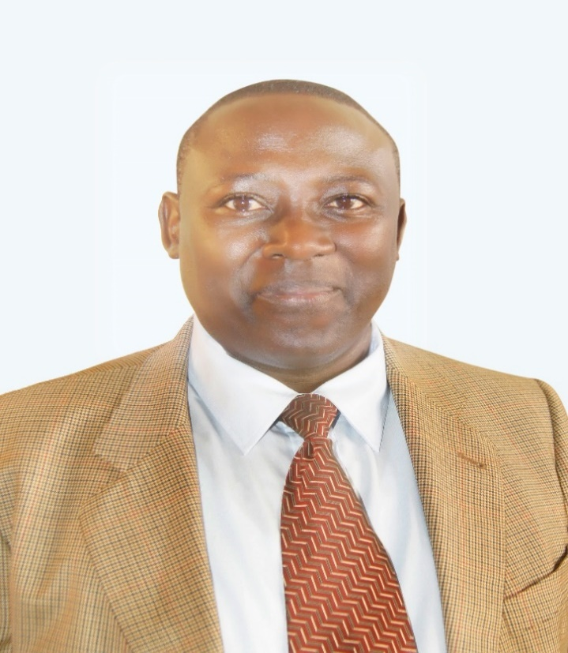
Dr. Joshua Mutambi, PhD Bio
Dr. Joshua Mutambi is a Commissioner and Head of Department of Processing and Marketing (Micro, Small and Medium Enterprises- MSMEs), in the Ministry of Trade, Industry and Cooperatives. He supervises and participates in formulation of Micro, Small and Medium sized Enterprises and Industrial development Policies, Strategies and programs. He coordinated different technology and industrial development programs such as African STI Indicators -Uganda program, Switch Africa Green- Demand-side Management of Energy use SMEs, Development of Green Manufacturing Strategy, Development and Promotion of MSMEs innovative Cluster Initiatives in Uganda, among others.
A Researcher, Sustainable industrial/manufacturing, competitiveness and enterprise development expert; with vast experience in facilitating development of MSMEs, Business Incubators, industrial parks, Research and Technical Institutions and Industrial cluster and Startup enterprises, among others. Previously worked for the former Uganda Airlines Engineering Department, Roofings Uganda Limited, Uganda Industrial Research Institute – Engineer in charge of the Equipping Machinery and installation project and Shanghai Omni Gear Manufacturing Company, China in charge of operations (design, machining, and testing).
Dr. Mutambi holds a PhD in Techno-science studies (Innovation Systems and Development) of Blekinge Institute of Technology in Sweden (2013) and a PhD in Engineering of Makerere University Kampala, Uganda (2014). Has a Licentiate (Masters) Degree of Technology from Blekinge Institute of Technology in Sweden (2011); a Master of Science in Engineering (Machine Manufacturing and Automation) from Shanghai University of Peoples Republic of China (2004), and a Bachelor of Science in Engineering-Mechanical (Upper Honors) of Makerere University, Kampala (1996) with a number of other science, technology and organizational management, Trade and Investment promotion, and Innovations management Post Training related Programs.
He also facilitates research and technology transfer/innovations for import substitution and industrial development through Academia such as Makerere University -College of Engineering, Design, Art and Technology (CEDAT), Makerere University Business School, Kyambogo University, Bishop Stuart University and other private sector Organizations. Serves other national Boards such as the National Enterprise Corporation (NEC) as a Board member, Board Member of Uganda Industrial Research Institute (UIRI), UNCST Council member and the 7th National Biosafety Committee member.

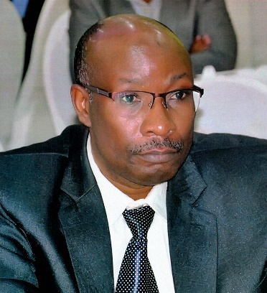
Assoc. Prof. Arthur K. Tugume; Contacts: tel. +256 772514841, +256 704514841; Email: arthur.tugume@mak.ac.ug and aktugume@gmail.com
Dr. Arthur Kajungu Tugume is a Ugandan scientist based at the College of Natural Sciences, Makerere University since October 1999 (then Faculty of Science). He holds a PhD (with a distinction) in Plant Pathology from the University of Helsinki, Finland (2010), an M.Sc in Crop Science (Genetics) (2003) and 2nd Class upper B.Sc (Botany and Biochemistry) (1999) both from Makerere University. He is Associate Professor of Plant pathology & virology since 2018 in the Department of Plant Sciences, Microbiology and Biotechnology, where he has played diverse leadership roles, e.g., being Head of the same Department twice in 2012-2015 and 2020-2022. Currently, he is the Dean, School of Biosciences (2022-2026), overseeing administration, academics and implementation of 17 diverse science academic programs in 4 Departments. He is the Chairperson of Makerere University Deans’ Forum, an association of Deans and Directors of academic units/institutes aimed at promoting good governance, networking and enhancing inter-disciplinary research. As a member of the University senate, he has served on numerous committees of the University senate in execution of his roles as Dean.

Dr. Tugume has been a Principal Investigator, Co-investigator, Coordinator, or Technical advisor for research projects of US$18,000 to US$6,200,000 budgets, with broad collaborative research networks in 12 countries spread globally across 5 continents. His research focuses on genetics; biotechnology; plant-microbe interactions; plant virus evolution, ecology, and transmission; plant pathology; and, plant sexual reproductive biology in diverse cultivated plant species and their wild relatives. Dr. Tugume has supervised and mentored numerous next generation scientists at postgraduate and undergraduate levels in the last 15 years. During this time, he has co-authored 43 scientific publications in international peer-reviewed journals. He is a reviewer for dozens of internationally recognized scientific journals as well for local and international granting (funding) organizations.

Dr. Tugume is the president of the Biology Society of Uganda (BioSU), and hence, at the forefront of motivating and promoting early interest in Biology amongst learners at O’ and A’ levels, as well as prime enrollment to university-level basic biological sciences. His interest was stimulated by a desire to cause positive change against the long-standing poor academic performance in Biology in Uganda’s national examinations. With keen interest in proper science governance, he is an ardent advocate for the creation a robust foundation in basic sciences on which to build all the other [applied] sciences if the science, technology and innovations (STIs) ecosystem is to survive, function and thrive.

Dr. Tugume is a Fellow of the Uganda National Academy of Sciences (FUNAS). He is also a member of the board of Trustees for the Makerere University Academic Staff Association (MUASA) Social Support Fund and Chair of the fund’s Finance, Administration and Investment committee. He is a co-founder (since 2011) of College of Natural Science Multipurpose Cooperative Society that seeks for financial independence of its members. As a member of the 6th National Biosafety Committee (NBC) of UNCST (2020-2024) and also for the 7th NBC (2025-2029), he is instrumental in policy guidance and regulation of biosafety, biotechnology, research investments and scientific applications for Uganda’s advancement.

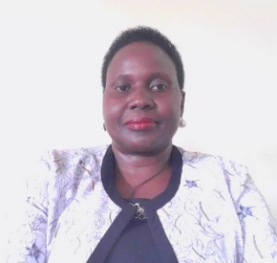
Dr. Mary Teddy Asio holds over 20 years of experience in agricultural development and research. She currently heads the National Seed Certification Services Division in Uganda, where she coordinates the inspection and certification of plant seeds in conformity with national and international control requirements, for improved food security, nutrition, and household income.
Her areas of expertise/interest include plant breeding and seed production.

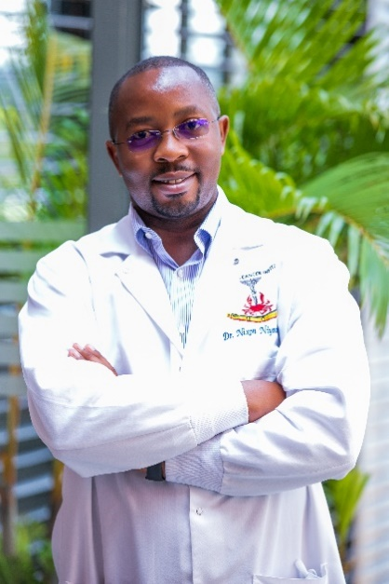
Dr. Nixon Niyonzima is a consultant and research scientist at the Uganda Cancer Institute. Dr. Niyonzima graduated with a Bachelor of Medicine and Surgery from Makerere University and a Master of Medicine in Pathology also from Makerere University. Dr. Niyonzima did a Master of Science in Global Health at Duke University and his doctoral studies in Molecular and Cell biology at the University of Washington (UW) where his dissertation focused on Gene Therapy. Dr. Niyonzima is currently the Head of Research and Training, and the Laboratory Director at the Uganda Cancer Institute. Dr. Niyonzima is an investigator on several studies including both academic and Industry clinical trials. Dr. Niyonzima’s research interests are the molecular characterization of cancers in Sub-Saharan Africa (SSA), affordable low-cost diagnostics for cancers in resource-limited settings and cancer health systems.

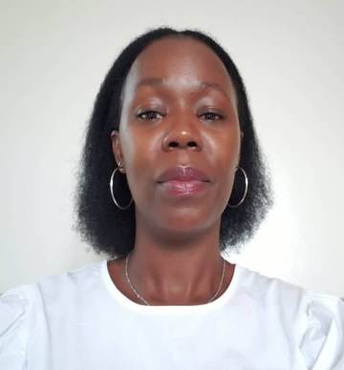
Sylveria Alwoch holds a master’s Degree in Human Rights, currently, a Senior program officer at Uganda National Health Consumers’/Users’ Organization, Sylveria has over 13 years working experience in community and policy engagement on patient safety, Patients’ Rights and Responsibilities, Knowledge management and Communications, building strategic partnerships and alliances with Civil Society, media and Government.

